Student Login

1. Username or Password is incorrect
2. Username or Password is Correct

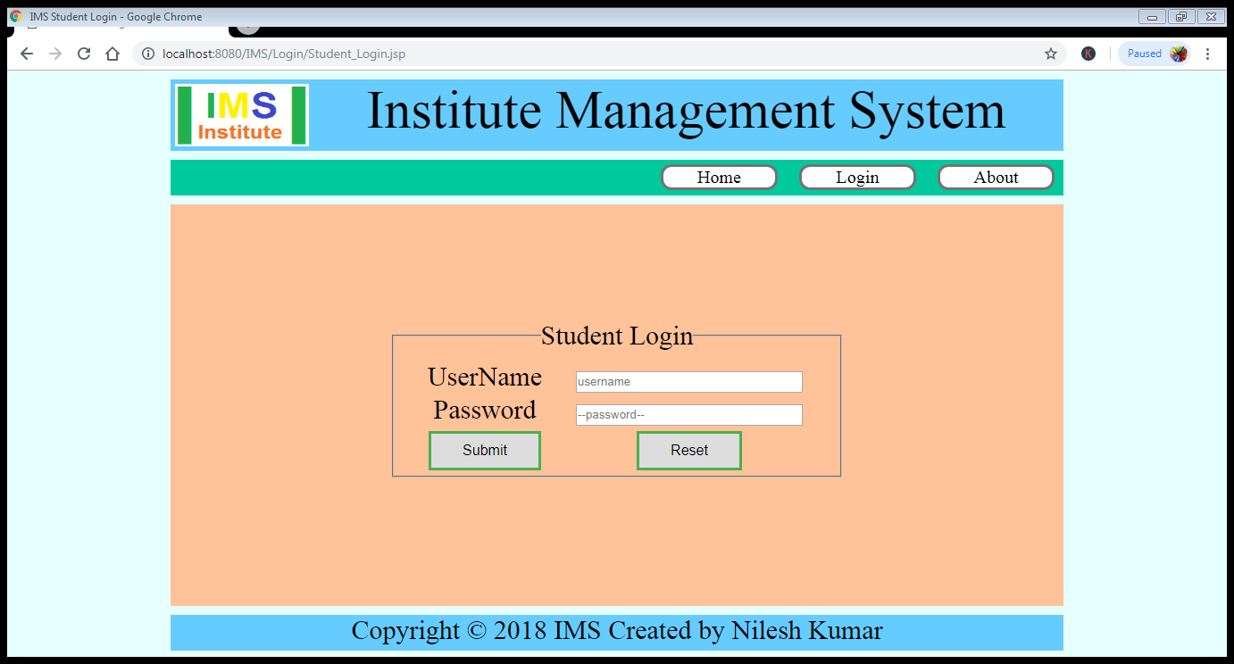

(a) Output When Username or Password is **incorrect** through ConfirmUser.jsp to Student_Login.jsp

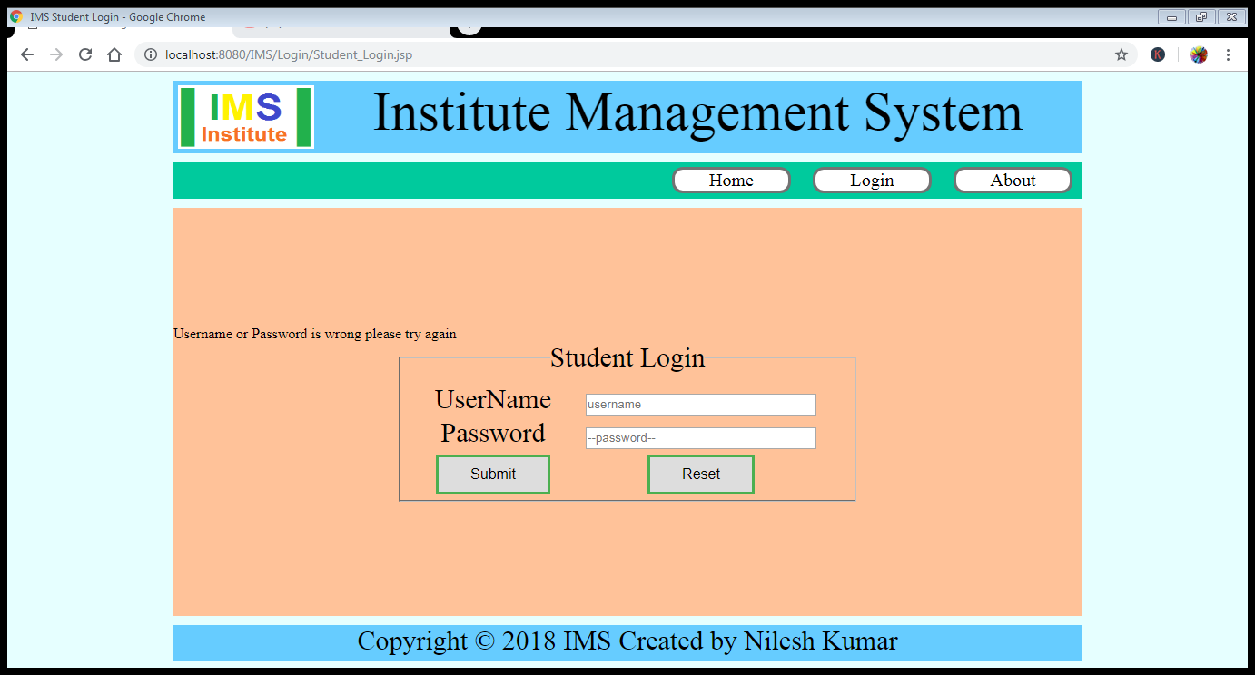

(b) Output When Username or Password is **Correct** through ConfirmUser.jsp to DashBoard.jsp

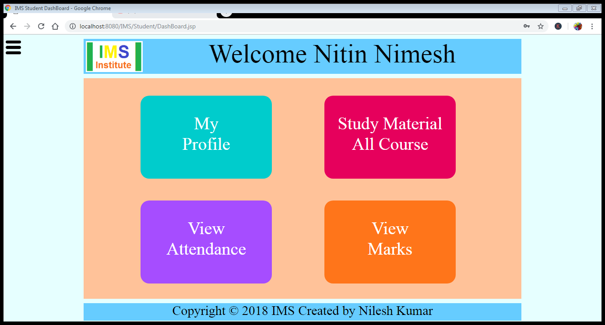

Clicking on My Profile it will open My_Profile.jsp page.

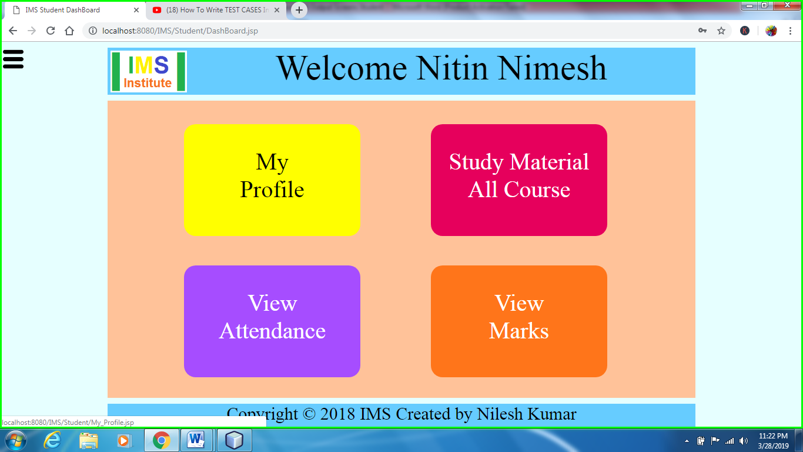

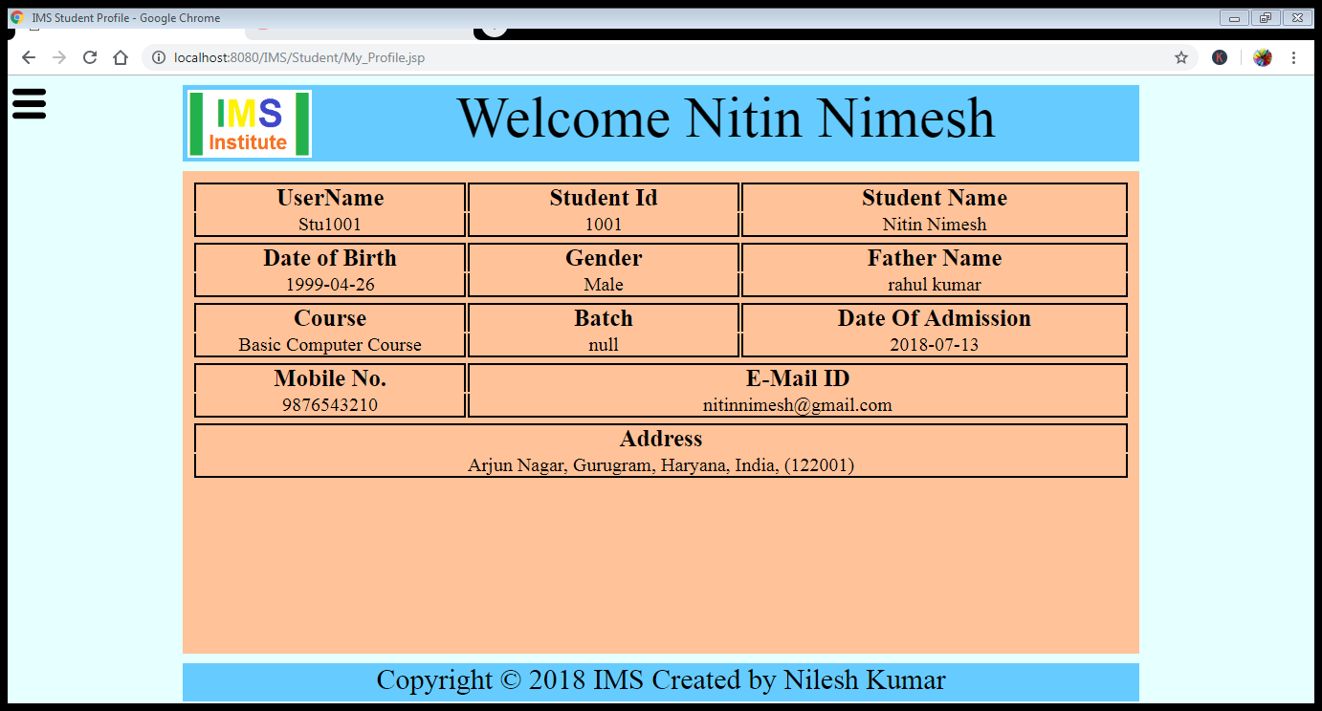

Click on view Course Detail and it will open Course_Detail.jsp page

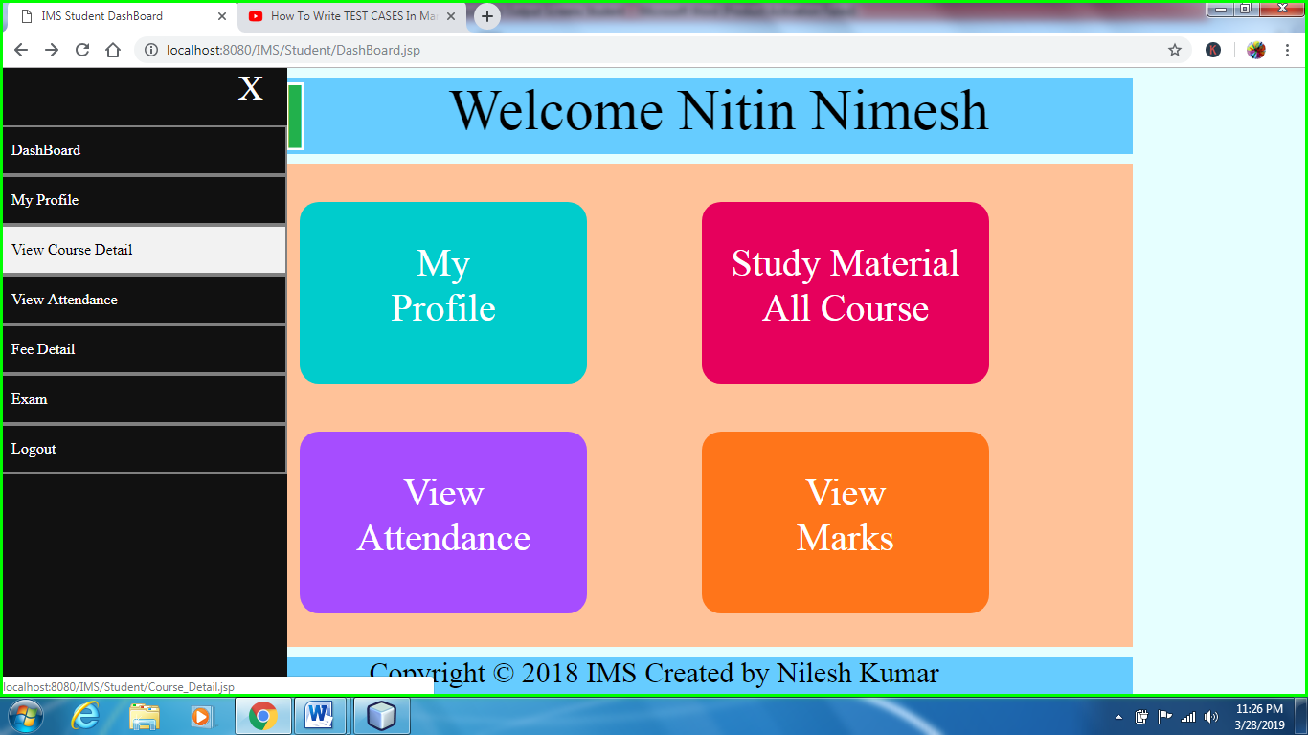

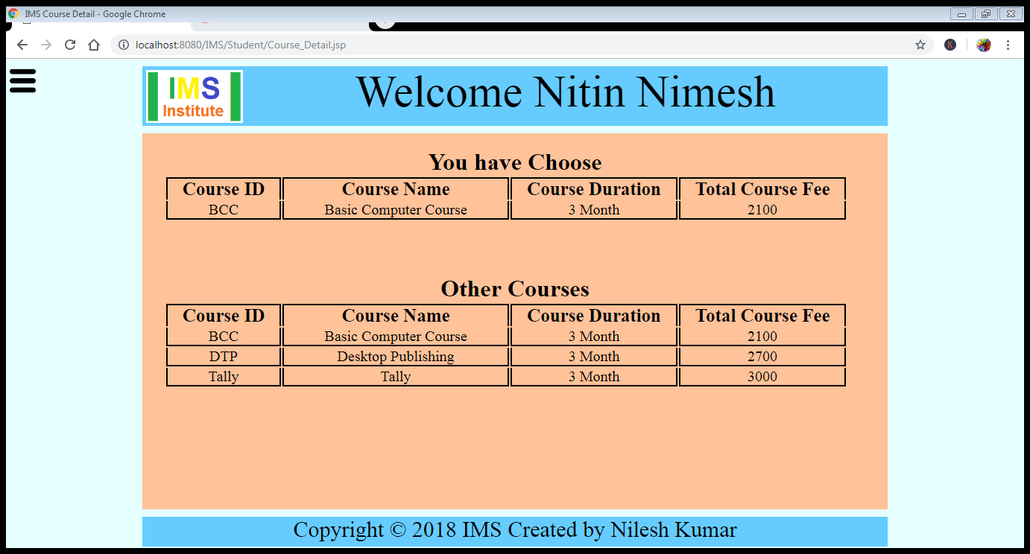

Click on view Attendance and it will open View_Attendance.jsp.jsp

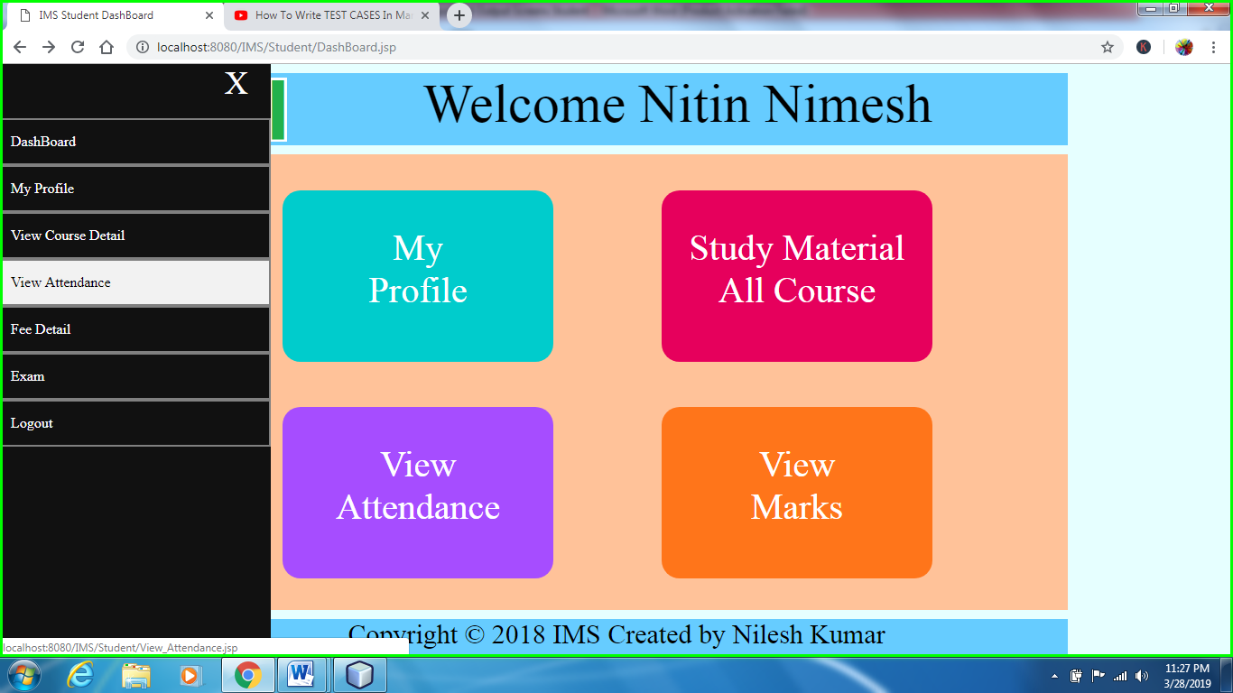

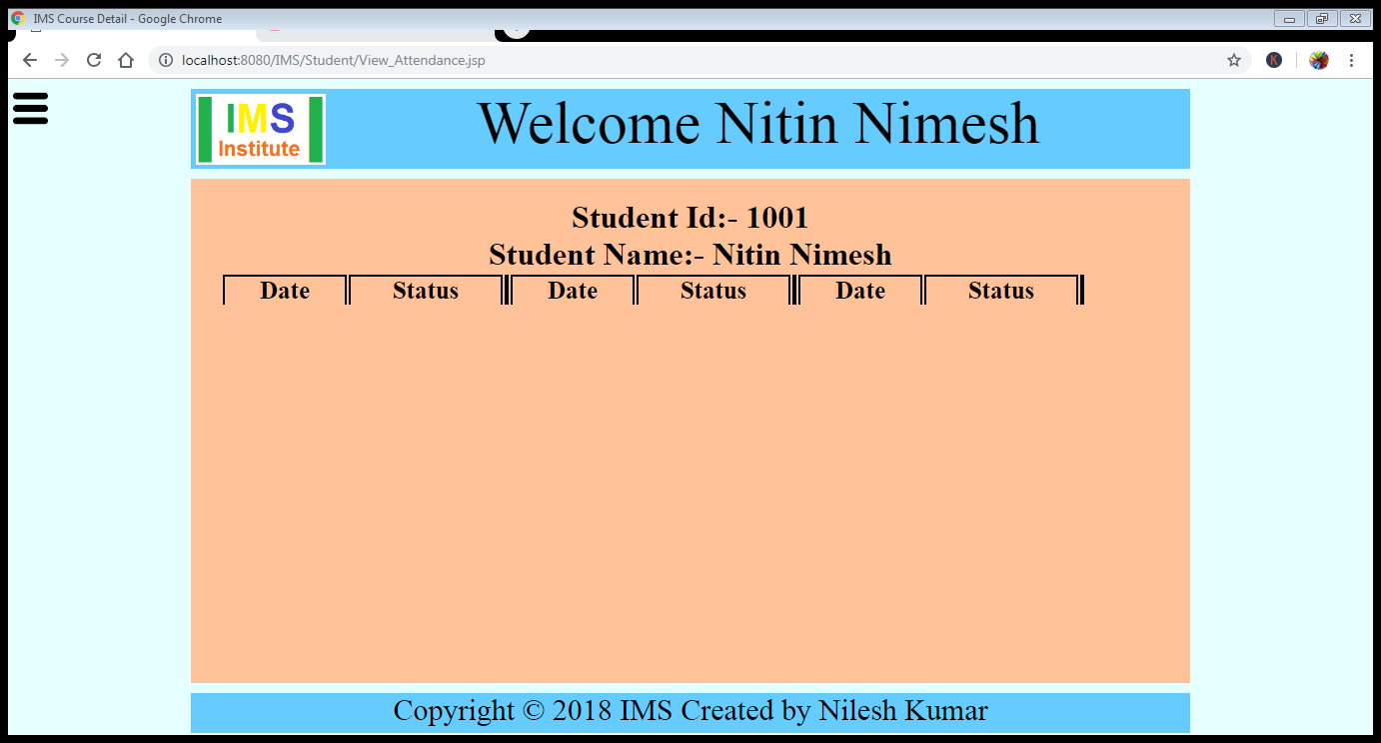

Click on Fee Detail and it will open Fee_Detail.jsp page

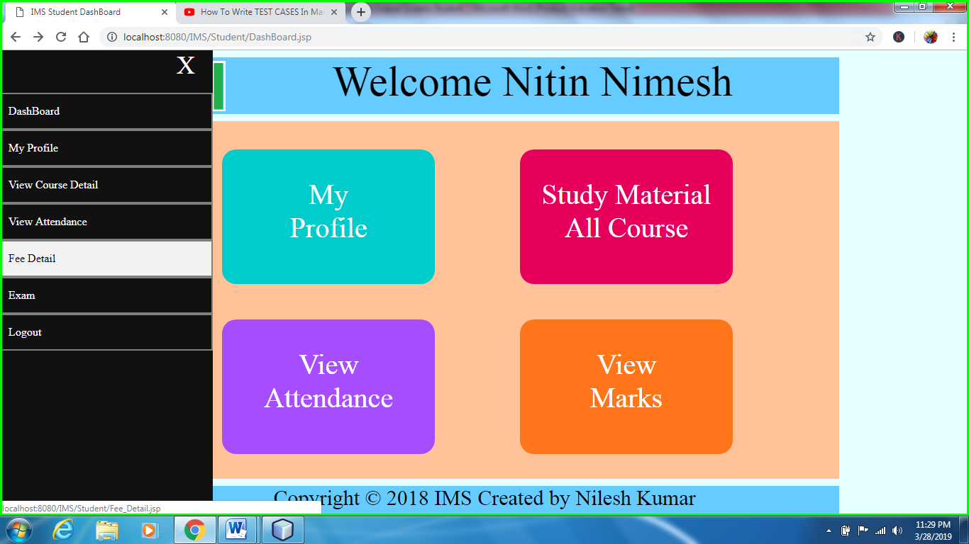

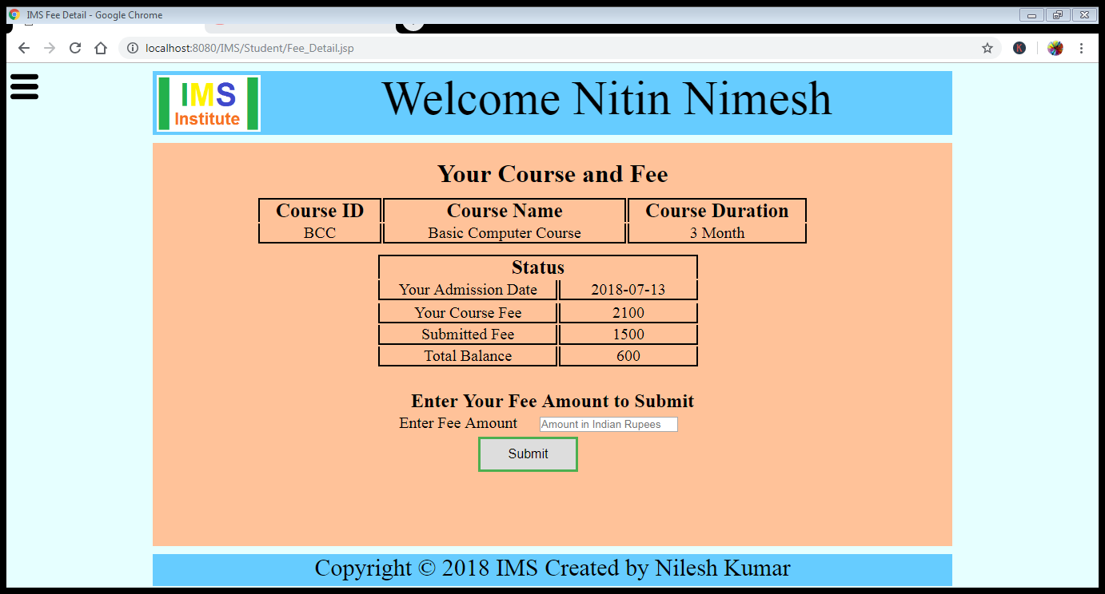

When student enter the amount and click on submit button the data is send to the Submit_Fee.jsp page

